NU Journal of Science and Technology Format of the Title of the paper
First Author, Second Author and Third Author

Department, Faculty, University, City, Postcode, Country
* Corresponding author. E-mail address: xxxxxx@xxxx.xx.xx
Received: xx January 2022; Revised: xx January 2022; Accepted: xx December 2022

Abstract
The abstract should summarize the content of the paper. The maximum number of words in the Abstract is 600. Do not have references or displayed equations in the abstract. The manuscript you prepare, and submit as a Word document, should be fully and correctly formatted. You must spell check and grammar check (F7). All text must be formatted by Style. If you don’t understand about Styles, view the videos on the Graduate School website.
The document format includes: Paper Size = A4, Orientation = Portrait, Margins = Top 2.5cm, Bottom = 2.5 cm, left = 3 cm, right = 2.5 cm, apply to whole document.

Keywords: journal format, printing, references (not more than 5 words)

Introduction

All the major headings are Heading 1 Style.
This is an example of a Normal paragraph, that is, a usual paragraph that has been stated as Normal Style. Submitted paper should be in English. There is a limit of 8-20 pages for each paper in the Journal.
The paper should have logical sections, Introduction, Methods and Materials, Results, Discussion, Conclusions and Suggestions, Acknowledgements, and References, in Heading 1 style.

Methods and Materials

Where sub-headings are used, they should be in Header 2 Style. The standard, or normal, paragraph should be in Normal Style. Where you have images or pictures that are .jpg format or other graphics format, you should format them as Wrap Text, Tight.

Example sub-heading: Inserting a Figure

Text following the Header 2 sub-heading

Results

Where sub-headings are used, they should be in Header 2 Style. The standard, or normal, paragraph should be in Normal Style. As is the case in all of the paper, paragraphs should be in Normal Style. When you are showing your results in tables, you should define a new style and call it TableDataStyle. Similarly, you should define a TableFigureLabelStyle. Using these 2 styles sets the formatting of those separately from Normal style. If you do not understand about this, you should view the videos on the Graduate School website.

Example sub-heading: Formatting Tables
Text following the Header 2 sub-heading, which should be in Normal Style.
Table 1 This is a brief label that links the table to your discussion (Example)
Position | Male |  |  | Female |  |  | Total
 | Left | Right |  | Left | Right |  | No. | (%)
1 | 0 | 0 |  | 1 | 0 |  | 1 | 0.21%
2 | 0 | 0 |  | 0 | 1 |  | 1 | 0.21%
3 | 56 | 49 |  | 138 | 133 |  | 376 | 40.09%
4 | 73 | 78 |  | 156 | 167 |  | 474 | 50.53% *
5 | 24 | 25 |  | 21 | 15 |  | 85 | 8.75%
6 | 0 | 1 |  | 0 | 0 |  | 1 | 0.21%
Total | 153 | 153 |  | 316 | 316 |  | 938 | 100%
* p < 0.05
Here you can enter any narrative or further information allowing the table to be fully understandable. But this is not the place for a full analysis and discussion of the data. That is done in the main text of the Results Section.
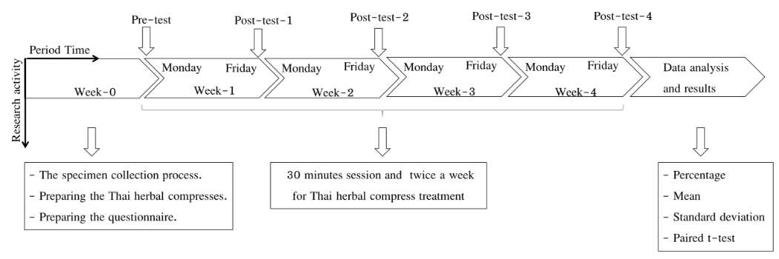

Figure 1 This is a brief label that links the table to your discussion (Example)

Discussion

Where sub-headings are used, they should be in Header 2 Style. Where sub-headings are used, they should be in Header 2 Style. The standard, or normal, paragraph should be in Normal Style.

Example sub-heading 3

Conclusion and Suggestions

In this section there may be sub-sections, with sub-section headings. These should be styled as Heading 2 style.

Acknowledgments

In this section you include all of the acknowledgments that you feel are necessary. If you do not wish to do this, then this section should be omitted. This text will be in Normal Style.

References

Hininger-Favier, I., Benaraba, R., Coves, S., Anderson, R. A., & Roussel, A. M. (2009). Green tea extract decreases oxidative stress and improves insulin sensitivity in an animal model of insulin resistance, the fructose-fed rat. Journal of the American College of Nutrition, 28(4), 355-361.
Moyers, R. E. (1988). Handbook of Orthodontics (4th ed.). London: Year book medical.
Pope, J., & Owen, A. D. (2009). Emission trading schemes: Potential revenue effects, compliance costs and overall tax policy issues. Energy Policy, 37, 4595-4603. http://dx.doi.org/10.1016/j.enpol.2009.
06.014
Prayag, I. L., & Ramjee, R. (2009). The impact of Newcastle disease control on smallholder poultry production in Mauritius. In R. G. Alsers, P. B. Spadbrow, & M. P. Young (Eds.), Village chickens, poverty alleviation and the sustainable control of Newcastle disease: Proceedings of an international conference held in Dar es Salaam, Tanzania, 5-7 October 2005 (pp. 132-134). Canberra, ACT: Australian Centre for International Agricultural Research.

